**LAB # 07 EXERCISES**

**Task 01:**

Your professor gives you CS1002 quiz which contains 10 different questions of multiple choice, each of which has three possible solutions one is easy, one moderate and one of difficult level. The difficult solution carries 5 marks, moderate carry 3 marks and easy carries 1 mark. Write a program which reads your solution and returns the total final marks on the screen. For each question, input which kind of solution you chose according to the following:

1. Difficult solution

2. Moderate solution

3. Easy solution

**Note. Use for loop.**

**Task-02**

You are taking two numbers as input from user, let’s consider first number is 128 and the second number is 2. After taking the input the first number is shifted two places to the right and the second number is doubled. The user wants you to write a program which meets the above mentioned requirements until the both the inputs become equal. Also print the final value of both numbers.

**Note: Use while loop only**

**Task 03:**

As your CL1002 exam is to be conducted in coming week-09. You are practicing for your exam, you thought to write a program which can takes an integer number as input and displays the message “CL1002 Exam is in week 09” number of times equal to the integer entered. You are also applying a constraint if the user continuously entering positive integer as input then your program executes as you enter a negative integer your program exits and returns the total number of times message displayed. Write the code for the above mentioned scenario which you thought.

Explanation: you are supposed to take as input a number (n). Your "do while" loop will try to run n times. In this loop, you will take input from the user for each iteration.

If this input is positive, then program will keep printing the statement ("CL1002 exam is in week 09").

If this input is negative, then the program must terminate after printing the amount of times the statement was printed.

**Note: Use do while loop**

**Task 04:**

You joined ACM society at your University and you assigned with a task for simulating the ticket procedure for 500 participants. you are asked to write a program for the mentioned task with following operations:

1. Purchase a ticket. The ticket price is PKR 100 for sophomores and 50 for juniors. You also offer 20% discounts who buy more than 3 tickets.

2. Displaying the number of seats available free and the total amount of sold tickets.

3. Termination of the program when user enters a certain input. When the program terminates also print the total tickets sold and total income generated by all sales.

**Note: Use while loop and switch statement**

**Task 05:**

Your teacher wants to test your mental math abilities, and asks you a question. He wants you to answer how many perfect squares there exist within a certain range of numbers. When the range is very large, you realise this problem is difficult to solve in your mind without using code.

Take as input the range (lower limit, upper limit) into your program and compute how many perfect squares there exist within that range. Output should print on the screen each perfect square that exists within the range, and at the end the total amount of perfect squares in the range.

**Example:** lower limit = 12, upper limit = 50.

In this range, the following perfect squares exist: 16,25,36,49. Total perfect squares = 4.

**Task 06:**

Write a C program to calculate **least common multiple** **(LCM)** of 2 numbers. For example, taking input of 2 numbers 8 and 12, the least common multiple is 24.

**Note: Use only single iteration. No nesting of loops.**

**Task 07:**

A palindrome number is defined as one which is the same forwards and backwards. For example, 121 is a palindrome. Reading from the left or the right, the number is the same – 121. Another example of a palindrome is 22.

In contrast, 354 is **not** a palindrome since it reads 354 from the left (forward), and 453 from the right (backwards).

Your task is to take any number as input from the user (in integer form) and check whether it is a palindrome or not, showing the result on the screen.

**Task 08:**

Take a number as input from user. Then, print the following pattern from 0 till n inclusive.

**Note: Solve it using single iteration loop, no nesting of loops is required.**

For example, if n = 8:

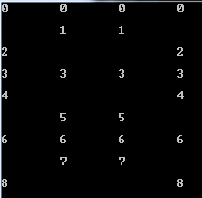

If n = 11:

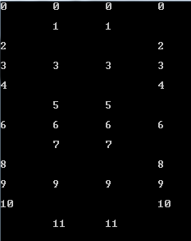

**Task 09:**

Perfect numbers are defined as a number whose sum of divisors (other than the number itself) is equal to the number itself

**For example, if A = 6:**

The divisors of 6: 1, 2, 3. Sum = 6. Therefore 6 is a perfect number

**For example, if A = 28:**

The divisors of 28: 1, 2, 4, 7, 14. Sum = 28. Therefore 28 is a perfect number.

Now, you are tasked with coding a program to check whether 2 numbers are mutually perfect. This means that given 2 numbers A and B, they are mutually perfect if the sum of divisors of A (other than A itself) is equal to B, and the sum of divisors of B (other than B itself) is equal to A.

For example, if A = 220, B = 284:

**The divisors of A are: 1, 2, 4, 5, 10, 11, 20, 22, 44, 55, 110. Sum = 284.**

So the sum of divisors of A is equal to B.

**The divisors of B are: 1, 2, 4, 71, 142. Sum = 220.**

So the sum of divisors of B is equal to A.

Hence, A and B are mutually perfect

**Task 10:**

Take a number as input from user. Then, print the following pattern from 0 till n inclusive.

For example, if n = 6:

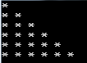

If n = 10:

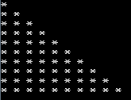

**Task 11:**

Take a number as input from user. Then, print the following pattern from 0 till n inclusive.

For example, if n = 6:

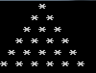

If n = 15:

